Tutorial #1 - What You Need to Know About the Tutorials

Habib Ghaffari

2022-09-19 Mon

Table of Contents
1. Introduction
2. Objectives of this tutorial
2.1. Learn How to Work With the Course's website
2.1.1. Resolve your problems
2.2. How to Install Python Interpreter:
2.2.1. Windows
2.2.2. Mac OS
2.2.3. Linux (Ubuntu)
2.3. IDE for Python Coding
2.4. Implement Our First Python Program
2.5. Simple Language

Introduction
My name is Habib Ghaffari Hadigheh. It is a mouthful name so you can simply call me Habib whenever you see me on campus. I am a fourth-year Ph.D. student under the supervision of Dr. Christopher Anand. My main area of research is Machine Learning (ML), Operations Research (Or) and Signal Processing. You can find information about how to contact me via my website at the following address Here.
ghaffh1
Today we are going to learn how to work with the course's website, how to install Python interpreter, and how to write our first program in python to make sure our interpreter is working properly. I am also going to introduce an IDE helps you to do coding much easier. If we have time I am also going to start working on a very simple language and try to write some programs based on it and see how our example program going to be evaluated.

Objectives of this tutorial
At the end of this session you should be able to :
- Learn to work with the website.
- Install the python interpreter in different operating systems.
- Install IDE for coding.
- Write our first Python program.
- Try to define a very simple language.

Learn How to Work With the Course's website
Here is the website address:
http://www.cas.mcmaster.ca/~franek/courses/cs3mi3/
On this website, you can find the course outline, a page for announcements and a link to sign in to your page. You should receive an email around a week ago with your username and password.
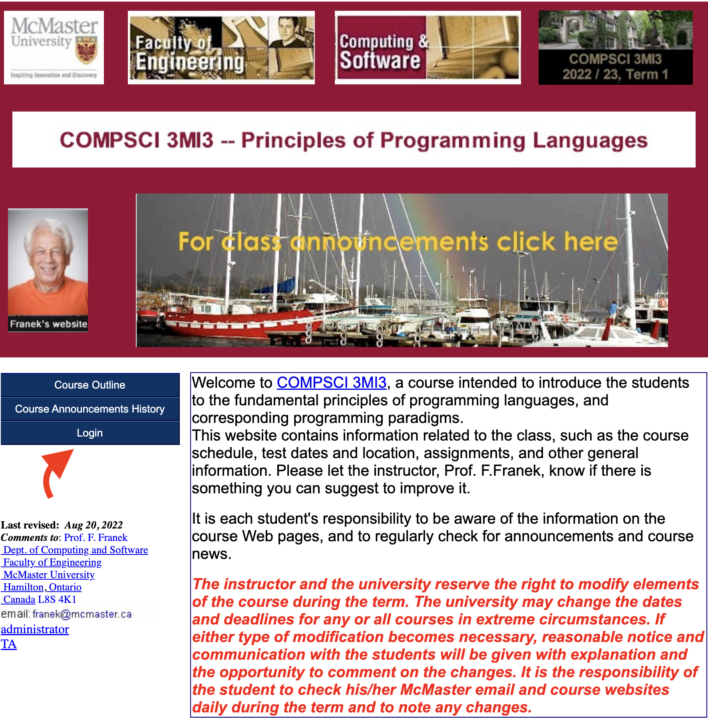 Figure 2.1.1: Course Page
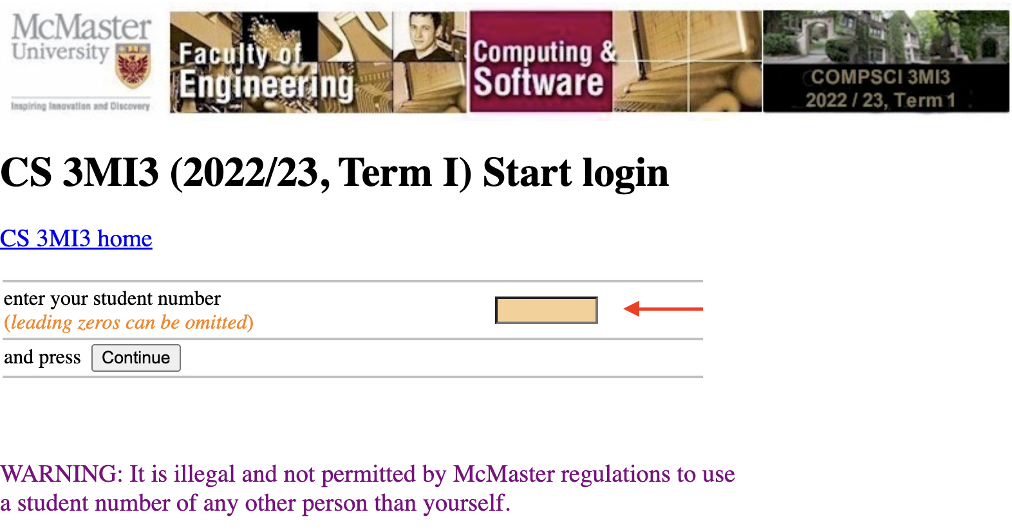 Figure 2.1.2: Login Page (Put your user name)
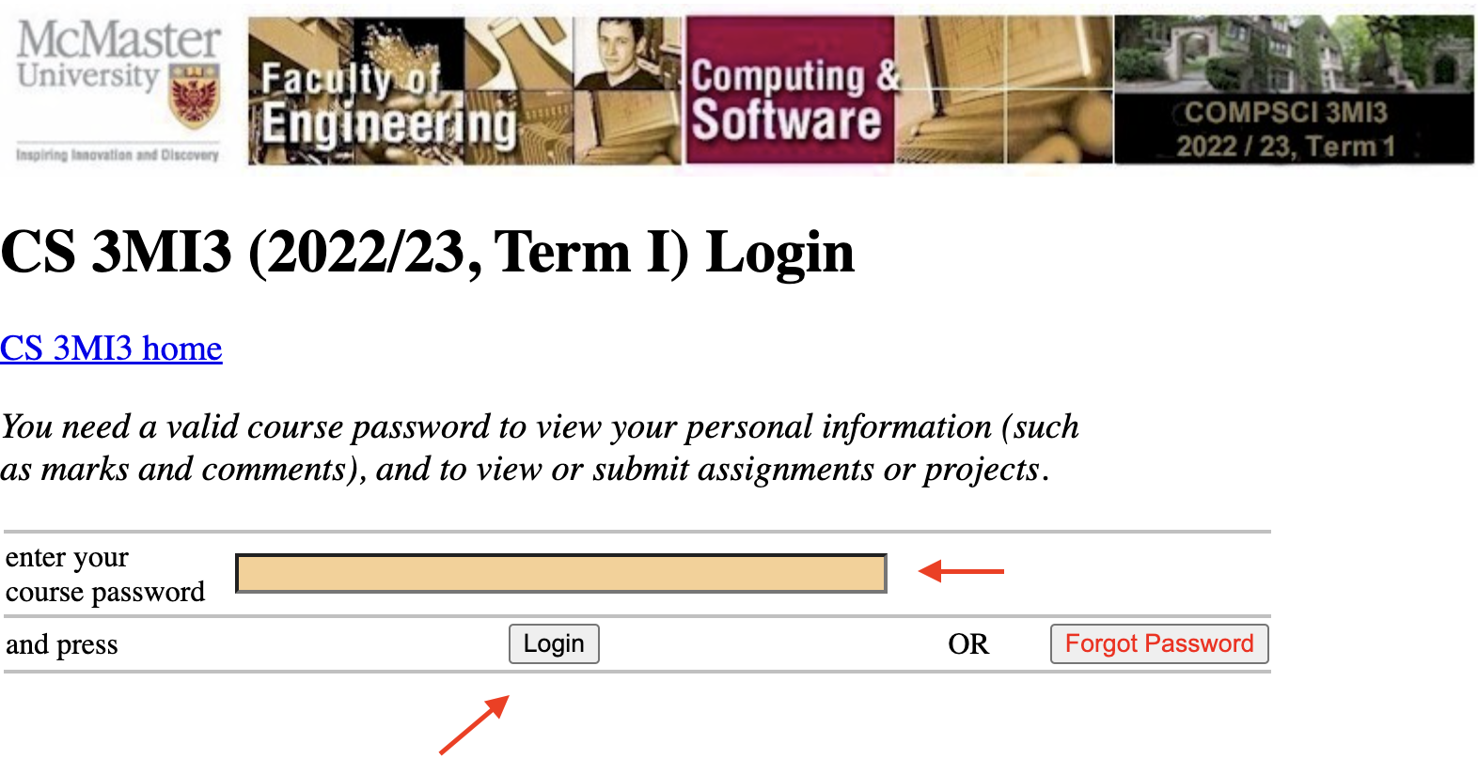 Figure 2.1.3: Login Page (Type your password)

Resolve your problems
- As TAs, we do not have any office hours, but we are available via email and you can schedule online/in-person meetings with any of us by emailing us.
- Problems with marking may happen in any course. If you think there is any problem with your marking or the comments/feedback you received is unclear, please contact me. I will figure out who marked your assignment/exam and make sure they provide you with more clarification about your mark. If you are still not satisfied I will ask another TA to mark your submission again. The final step would be for either me or Dr. Franek to look at your solution and make the final decision.

How to Install Python Interpreter:

Windows
There are a few methods to install Python interpreter on your machine. The straightforward method is to use Python website.
https://www.python.org/
Another method is to use Chocolatey. You can install Chocolatey using the following link:
https://chocolatey.org/install
Then you can simply use the following link to install a version of Pthon on your machine:
https://community.chocolatey.org/packages/python/3.9.1
Another method is to use Anaconda:
https://www.anaconda.com/

Mac OS
Mac OS should have an in-built Python version pre-installed on the Machine. However, you can easily install a version based on your preferences:
The straightforward method again is to use the website:
https://www.python.org/downloads/macos/
But the most preferable method is to use Homebrew. You can install HomeBrew on your machine using the following link:
https://brew.sh/
The next step is to use the following instruction to install any version of python you want:
brew install python

Linux (Ubuntu)
Installing Python on a Linux (Ubuntu) machine is very easy. Just type the following command in your terminal
sudo apt-get install python

IDE for Python Coding
You can use almost any editor to implement python programs. However, the best well-known IDE is Pycharm:
https://www.jetbrains.com/pycharm/

Implement Our First Python Program
Let's implement our Hello World program in Python.
print("Hello World!!")

Simple Language
Let's have a look at the BNF as you know it:
<postal-address> ::= <name-part> <street-address> <zip-part>

<name-part> ::= <personal-part> <last-name> <opt-suffix-part> <EOL> | <personal-part> <name-part>

<personal-part> ::= <initial> "." | <first-name>

<street-address> ::= <house-num> <street-name> <opt-apt-num> <EOL>

<zip-part> ::= <town-name> "," <state-code> <ZIP-code> <EOL>

<opt-suffix-part> ::= "Sr." | "Jr." | <roman-numeral> | ""
<opt-apt-num> ::= <apt-num> | ""
This translates into English as:
- A postal address consists of a name-part, followed by a street-address part, followed by a zip-code part.
- A name-part consists of either: a personal-part followed by a last name followed by an optional suffix (Jr., Sr., or dynastic number) and end-of-line, or a personal part followed by a name part (this rule illustrates the use of recursion in BNFs, covering the case of people who use multiple first and middle names and initials).
- A personal-part consists of either a first name or an initial followed by a dot.
- A street address consists of a house number, followed by a street name, followed by an optional apartment specifier, followed by an end-of-line.
- A zip-part consists of a town-name, followed by a comma, followed by a state code, followed by a ZIP-code followed by an end-of-line.
- An opt-suffix-part consists of a suffix, such as "Sr.", "Jr." or a roman-numeral, or an empty string (i.e. nothing).
- An opt-apt-num consists of an apartment number or an empty string (i.e. nothing).
The language we are going to define contains just a handful of syntactic forms: the boolean constants true and false, conditional expressions, the numeric constant 0, the arithmetic operators succ (successor) and pred (predecessor), and a testing operation iszero that returns true when it is applied to 0 and false when it is applied to some other number.
<t> ::= Term
T Constant True
F Constant False
0 Zero
if t then t else t Conditional Expression
succ t Successor
pred t Predecessor
iszero t Zero Test
A program in the present language is just a term built from the forms given by the grammar above. Here are some examples of programs, along with the results of evaluating them:
if (F) then 0 else (succ 0);
> succ 0

iszero (pred (succ 0));
> T
What is the evaluation result of the following programs?
> if (succ 0) then 0 else pred (succ (succ (0)));
> if 0 then T else F;
> iszero (T);
Exercise:
- How could we evaluate the above expression?
Now let's define the above language using Haskell programming language:
data term =
T -- True Constant
|F -- False Constant
|Zero -- Zero Constant
|Succ term -- Successor
|Pred term -- Predecessor
|IfThenElse term term term -- Conditional Expression
|IsZero term -- Zero Test
Exercise:
- How could we define the language rules using Haskell?
- Is it possible to define this language in Python? If yes then how?

